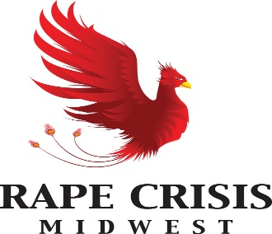

RCNI SEXUAL VIOLENCE SPECIALISATION TRAINING FOR COUNSELLORS IN RAPE CRISIS CENTRES

APPLICATION FORM

Rape Crisis Midwest
Phoenix House,
Punch’s Close,
Rosbrien Road
Limerick

Tel: 061 311511
Email info@rapecrisis.ie
www.rapecrisis.ie
Personal Details:

Name:

Address:

Mobile No:

Email address:

Date of Birth:

Counselling Qualifications: ………………………………………………………………………..

Other Relevant Qualifications: ……………………………………………………………………

Accreditation Body & Status of Accreditation: ………………………………………………….

1. GIVE YOUR REASONS FOR WISHING TO PARTICIPATE IN THIS TRAINING

2. IF YOU HAVE ANY EXPERIENCE OF THE FOLLOWING PLEASE GIVE DETAILS:

(a) WORKING WITH WOMEN’S / MENS / COMMUNITY / MENTAL HEALTH GROUPS.

(b) COUNSELLING (PLEASE GIVE DETAILS OF TRAINING RECEIVED)

(c) WORKING WITH OTHER ORGANISATIONS (PLEASE STATE WHICH ORGANISATION AND THE NATURE OF YOUR INVOLVEMENT:

3. WOULD YOU REGARD YOURSELF AS A FEMINIST? YES NO (please tick)

IF YES, HOW WOULD YOU OUTLINE YOUR FEMINISM?

IF NO, PLEASE COMMENT ON THIS:

4. WHY DO YOU THINK RAPE / SEXUAL VIOLENCE EXISTS?

- PLEASE GIVE A BRIEF PERSONAL HISTORY:

………………………………………………………………………………………......

………………………………………………………………………………………….

- HAVE YOU HAD PREVIOUS INVOLVEMENT WITH A RAPE CRISIS CENTRE?

- ARE THERE ANY COMMENTS YOU WOULD LIKE TO MAKE?

PLEASE RETURN COMPLETED APPLICATION FORM TO:

Dr. Michelle Walsh

RAPE CRISIS MIDWEST
PHOENIX HOUSE
PUNCH’S CLOSE
ROSBRIEN ROAD
LIMERICK.

Tel: 061 311511 Email: michelle.walsh@rapecrisis.ie

CLOSING DATE FOR RECEIPT OF APPLICATIONS: 30/06/2022.

